SIMATS ENGINEERING
ASSESSMENT TOOL 2: CASE STUDY

COURSE NAME: Cloud Computing and
Big Data Analytics

COURSE CODE: CSA15

COURSE OUTCOME COVERED
CO3: Implement cloud-based solutions using cloud storage, web APIs, and platform services for real-world
applications. (BL3)
Assessment Tool Weightage: 40%
Dave&#39;s Taxonomy: Precision (Level 3)
Question Count: 5

Total Marks: 40

Code of Conduct
I ARTHIREDDY(192565054)(Name / Reg No) certify that this submission is my original work and that I have adhered
to the guidelines specified for this assessment.
I understand that any violation of academic integrity rules will result in disciplinary action.
Signature of the student: arthireddy
Assessment Tasks
Case Study
1. Case 1: A food delivery company wants to deploy a cloud-native backend with web APIs, browser clients, and
shared cloud storage for receipts and delivery images. Propose the architecture and explain the role of each
component.
2. Case 2: A media startup must decide between SAN-backed storage, object storage, and serverless processing
for video upload workflows. Analyze the case and recommend a deployment model.
3. Case 3: A smart city platform needs low-latency decision making near sensors while still using the cloud for
analytics. Analyze the use of edge computing and fog computing in this environment.
Case Study Rubric

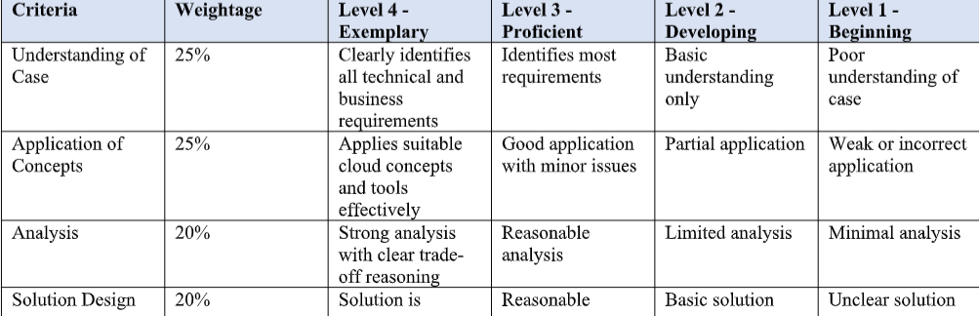

Cloud Computing – Case Study Answers
Case 1: Food Delivery Cloud-Native Backend
Proposed Architecture
Customers / Delivery Agents
|
v
Web / Mobile Browser
|
HTTPS
|
v
API Gateway
|
v
Cloud Web APIs
/ | \
/ | \
v v v
User Order Payment
Service Service Service
\ | /
\ | /
v v v
Cloud Database
|
v
Object Storage
/ \
Receipts Delivery Images
|
v
Monitoring
Role of Each Component
- Browser/Mobile Client
Customers use it to browse restaurants, place orders, track deliveries, and make payments.
- API Gateway
Acts as the entry point for client requests and routes them to the appropriate backend service.
- Web APIs
Handle business operations such as user management, restaurant information, orders, payments, and delivery tracking.
- Cloud Database
Stores structured information such as customer details, orders, restaurant information, and delivery status.
- Object Storage
Stores large unstructured files such as receipts, food images, and delivery proof images.
- Authentication
Verifies customers, delivery agents, and administrators before allowing access.
- Monitoring Service
Tracks API performance, errors, resource usage, and application availability.
Conclusion
A cloud-native architecture using API services, cloud databases, and object storage provides scalability, flexibility, and reliable access for a food delivery company.

Case 2: Media Startup – Video Upload Workflow
Problem
The startup needs to handle large video files and process them after upload. Three possible technologies are:
Technology | Advantages | Limitations | Suitable Use
SAN Storage | Very high performance | Expensive and infrastructure-heavy | High-performance internal workloads
Object Storage | Highly scalable, durable, cost-effective | Not ideal as a traditional disk | Video storage and backups
Serverless Processing | Automatic scaling, no server management | Execution limits/cost considerations | Video processing tasks
Recommended Architecture
User
|
v
Web / Mobile App
|
v
Upload API
|
v
Object Storage
|
Upload Event
|
v
Serverless Function
|
v
Video Processing
|
+------+------+
| |
v v
Processed Video Metadata
| |
v v
Object Storage Database
Analysis
SAN-backed storage:
Provides high-speed block-level storage but requires more infrastructure and can be expensive for a startup. It is better when applications require high-performance shared storage.
Object storage:
Is highly suitable for videos because videos are large unstructured objects. It provides scalability and durability without requiring the startup to manage physical storage infrastructure.
Serverless processing:
Can automatically process uploaded videos when an upload event occurs. Examples include generating thumbnails, transcoding smaller versions, and extracting metadata.
Recommendation
The startup should use a combination of:
Object Storage + Serverless Processing + Cloud Database
This model provides:
- Low infrastructure management
- Automatic scaling
- Cost efficiency
- Large storage capacity
- Event-driven video processing
Conclusion
For a media startup, object storage should be the primary video storage, while serverless services should process videos automatically. SAN can be avoided unless specialized high-performance requirements justify its cost.

Case 3: Smart City – Edge and Fog Computing
Problem
A smart city collects data from traffic cameras, pollution sensors, parking sensors, and other IoT devices. Immediate decisions must be made close to the sensors, but the cloud is required for large-scale analytics.
Proposed Architecture
Smart City Sensors
/ | \
Traffic Pollution Parking
Cameras Sensors Sensors
\ | /
v
Edge Devices
|
Immediate Analysis
|
v
Fog Node/Gateway
|
Regional Processing
|
v
Cloud Platform
|
Big Data Analytics
|
v
Reports / Predictions
Role of Edge Computing
Edge computing processes data very close to the sensors or devices.
For example:
- A traffic camera detects heavy traffic.
- The edge device analyzes the video immediately.
- The traffic signal is changed without waiting for the central cloud.
Benefits:
- Very low latency
- Fast decision-making
- Reduced network traffic
- Works even when cloud connectivity is temporarily unavailable
Role of Fog Computing
Fog computing provides an intermediate processing layer between edge devices and the cloud.
For example:
- Several traffic signals send data to a local fog gateway.
- The fog node analyzes traffic conditions across an area.
- It coordinates traffic signals before sending summarized information to the cloud.
Benefits:
- Regional coordination
- Lower bandwidth usage
- Low latency
- Better scalability than sending everything directly to the cloud
Role of Cloud
The cloud handles tasks that do not require immediate responses:
- Historical data storage
- City-wide analytics
- Machine learning
- Traffic prediction
- Long-term reports
- Dashboard visualization
Edge vs Fog vs Cloud
Feature | Edge | Fog | Cloud
Location | Near sensor | Local/regional network | Central datacenter
Latency | Very low | Low | Higher
Processing | Immediate decisions | Regional decisions | Large-scale analytics
Example | Traffic signal control | Area traffic coordination | City-wide traffic prediction
Conclusion
A hybrid Edge–Fog–Cloud architecture is best for a smart city. Edge computing handles immediate decisions, fog computing coordinates nearby devices, and cloud computing performs large-scale analytics and long-term storage.

